ART & DESIGN
Investigation 1a

Try this
classroom activity

Commemorative coin design

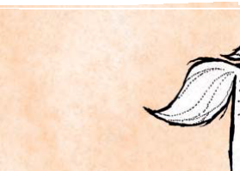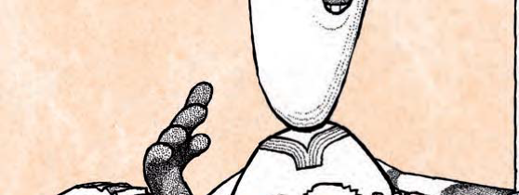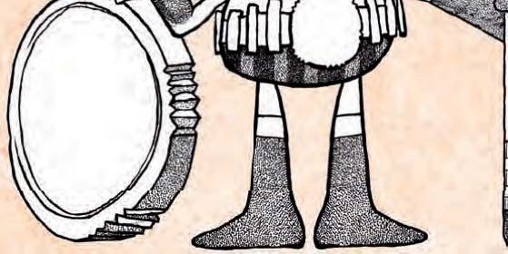If you were able to design your own commemorative coin, what would be on it? Would it be something important to you
or something important to all Australians? What theme would you select? Would it be:

Flora (Flowers and Plants)
Fauna (Animals)
Sports
Famous Faces
or the anniversary of something special?

Would the picture be enough to explain the coin? Or would you need to add some descriptive words or an inscription? Remember there is not a lot of space on
a coin so you would have to choose your words very carefully.
How much is your coin worth? Is it $2, $1,
50c, 20c, 10c, or 5c? Or is a different amount?
You will need to include the amount
somewhere on the coin so the collector
knows how much they can spend!

What is your coin made of ? If you made your coin from cake, it wouldn’t last very long!
You need your coin to last a long time. Coins are generally expected to last about
30 years in circulation and even longer when they are not being used.

Primary

PAGE 1

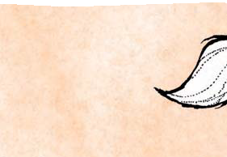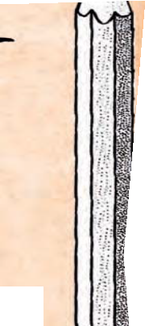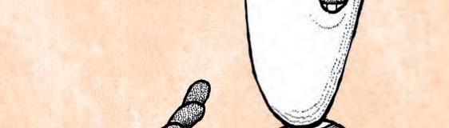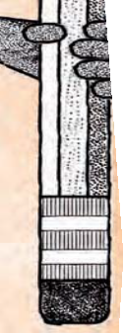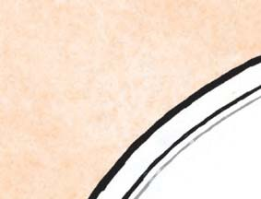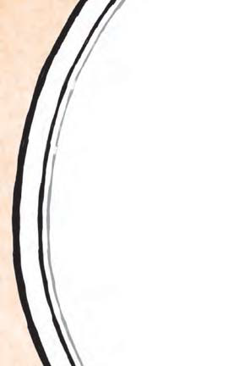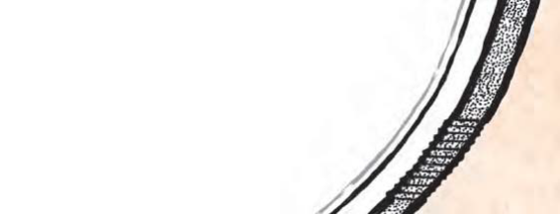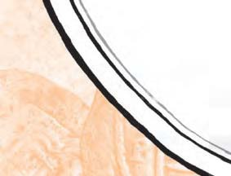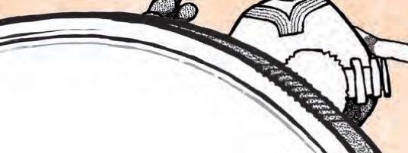ART & DESIGN
Investigation 1a

Sketch your coin design here with me

Commemorative coin design

ry
Prima

PAGE 2

